**C ++ LANGUAGE NOTES**

* Endl-new line
* Cout -output
* Cin-input
* ::-resolution operator
* *by default decimal number is double
* Float =34.4f;
* Long double =34.4l;
* indication of the data type;
* Sizeof(34.4f)---c++ keyword
* **REFEERENCE VARIABLES** int a=9;
* int &b=a;
* cout<<a<<b;
* **TYPE CASTING**

Float b=8.88;

Int(b)

Const int a =3;-----Constant declaration,cant change the variable….read only variable

* #include <iostream>

**#include<iomanip>//manipulator header file**

using namespace std;

int c=50;

int main()

{

int a=9,b=10;c=8888;

**cout<<setw(4)<<a<<endl<<setw(4)<<b<<endl<<setw(4)<<c<<endl;//setw() manipulator**

return 0;

}

* **POINTER ARITHEMATIC**

Address new= address current + I*size of data type

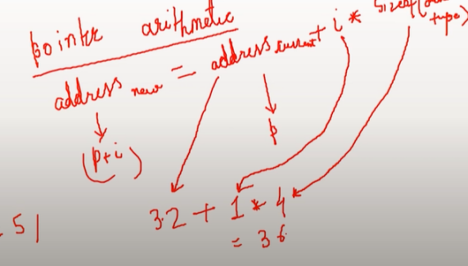

In an array----->   
int marks[4];

Int *=marks;

Cout<<*p; ------(WILL STORE THE FIRST VALUE OF THE ARRAY)

Cout<<*(p+1); next value and so on

**STRUCTURE**

Struct room  **OR**

Typedef struct room

{

Int id;

Char id1;

}ro;

Int main ()

{

Ro first;

First.id;

First.id1;}

}

{

Int id;

Char id1;

};

Int main()

{

Struct room r;

1. id;
2. Id1}

**UNION ----ONLY 1 DATA TYPE AT A TIME ,OVERRIDES THE MEMORY IF DECLARED AGAIN**

Union room

{

Int id;

Char id1;

}

REST SAME AS STRUCT

**Enum** Meal {breakfast,lunch,dinner}

**------>Converts to integer**

Meal m1=breakfast;

Cout<<m1;

* #include<cstdlib>

Abs(num)----> absolute value of num

* Inline int product(int a, int b)---> for small codes and repetitive work
* Static int c=0;---> value retained,runs only 1time
* Include<string>

String s;

S=To_string(value);

* **//OBJECT ORIENTED PROGRAMMING---> classes and objects**

#include<iostream>

using namespace std;

class bank

{

private :

int acc_num;

int mobileno;

int id;

public :

int bal;

void getdata(int acc_num,int mobileno,int id);

void printdata()

{

cout<<"YOUR ACCOUNT BALANCE IS"<<bal;

}

};

void bank::getdata(int acc_num,int mobileno,int id)

{

cout<<"enter your account number"<<endl;

cin>>acc_num;

cout<<"enter your mobileno"<<endl;

cin>>mobileno;

cout<<"enter id"<<endl;

cin>>id;

}

int main()

{

int a,b,c;

bank b1;

b1.bal=1000000;

b1.getdata(a,b,c);

b1.printdata();

return 0;

}

* #include<string>

s.length()---> to generate the length of the string

S.at(i)---> to get the character/word at a particular index of th string

* Static int count;---> default value 0
* Static int getcount();---> function used to access static datatypes or members
* Cout.widh(5);---> for spaces in the output
* Identifier of an array is a pointer.
* New---> new memory allocation
* Delete---> delete the memory location
* Time(NULL)-->changes value every time we run the code
* Srand(1933782)-->seeds
* Rand()---> generates a random number but the value remains same everytime we execute the program.
* Name of the array is the first element of the array to which the pointer points
* Strcmp(x,y)---> 0 means both strings are of same size,1 means first string is larger.-1 first string is smaller.
* 